**EXPERIMENT – 1**

* **R2142220816**

1. Account Login

AWS:

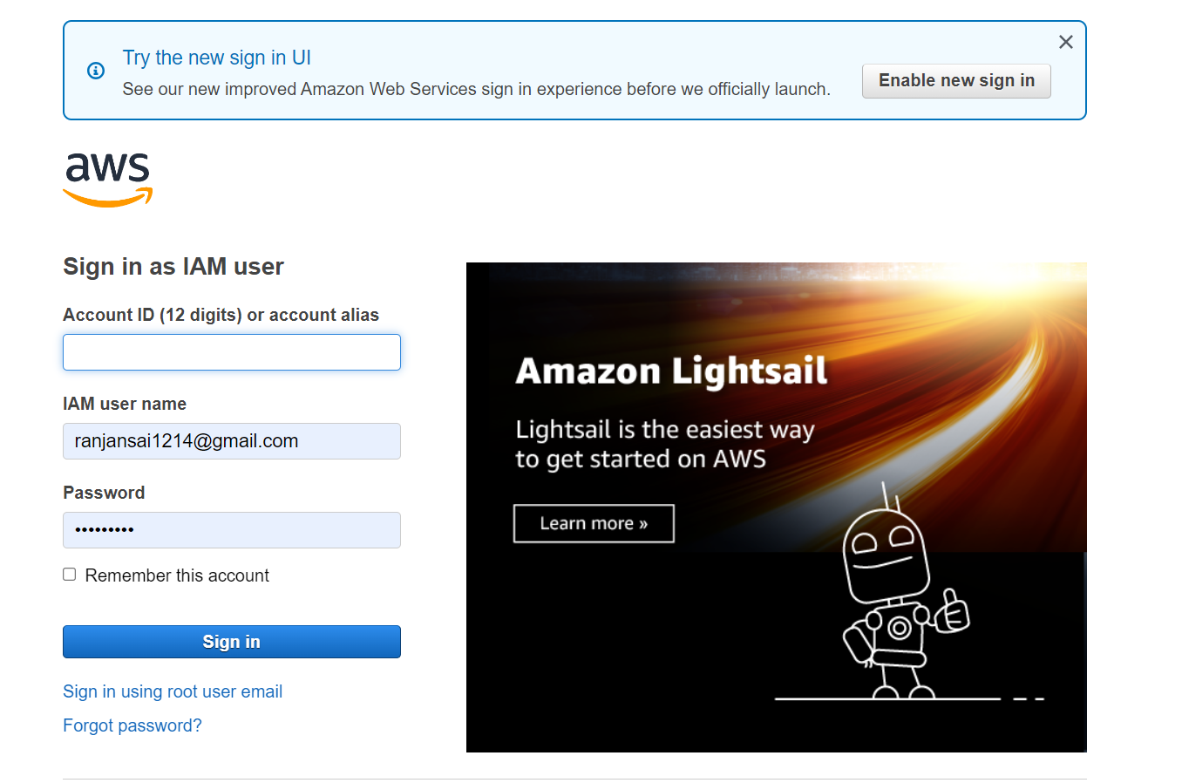

GCP:

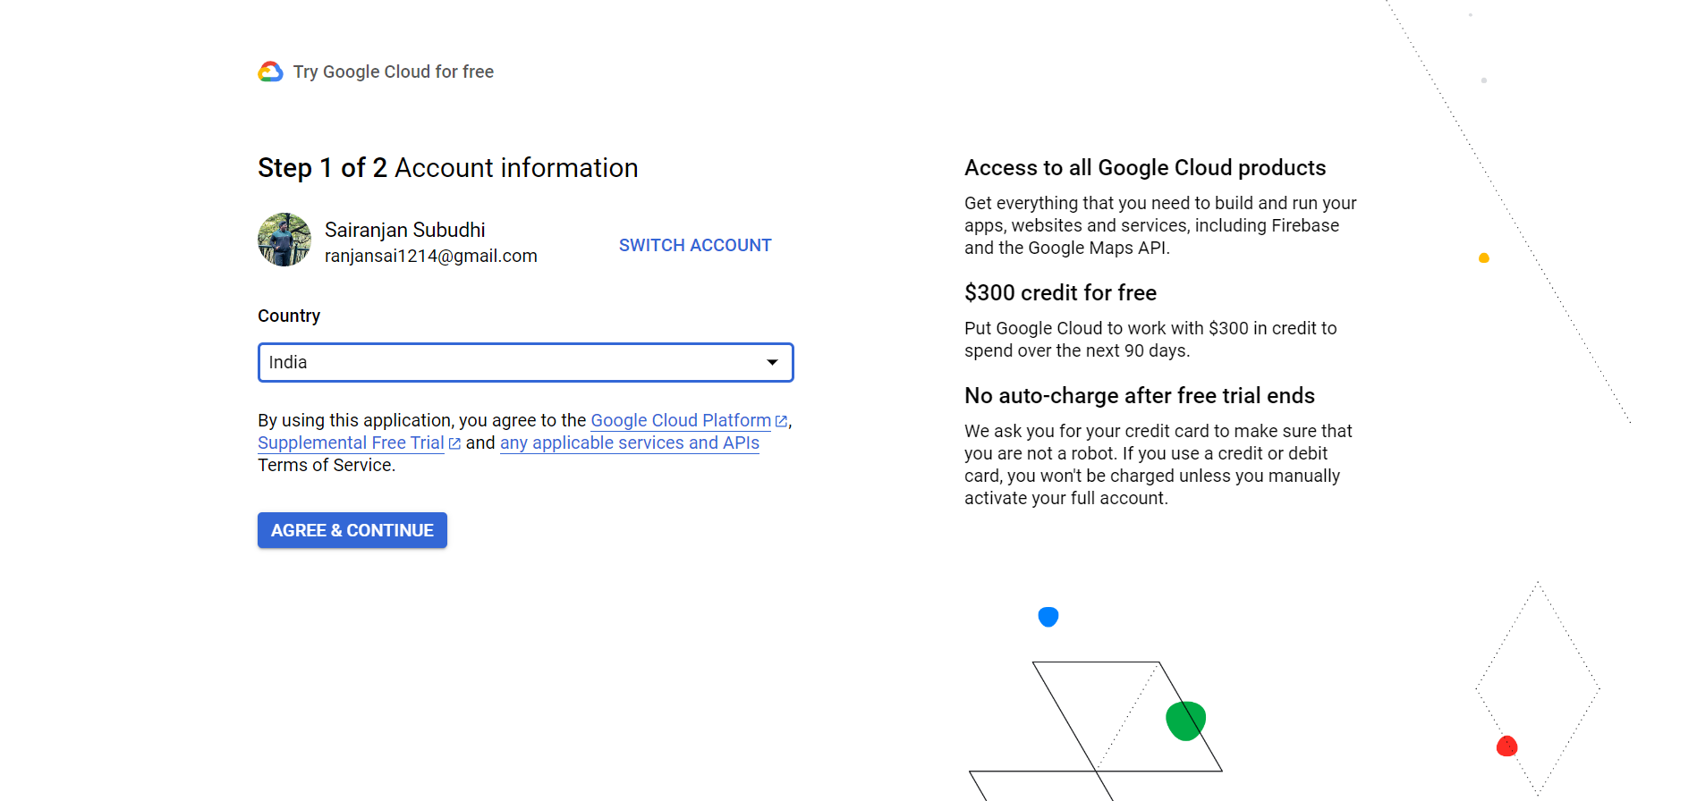

Azure:

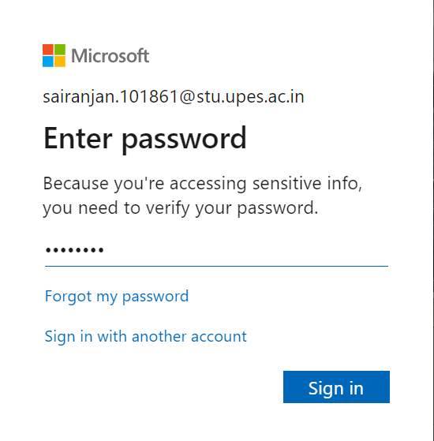

1. Free Tier

AWS:

––––––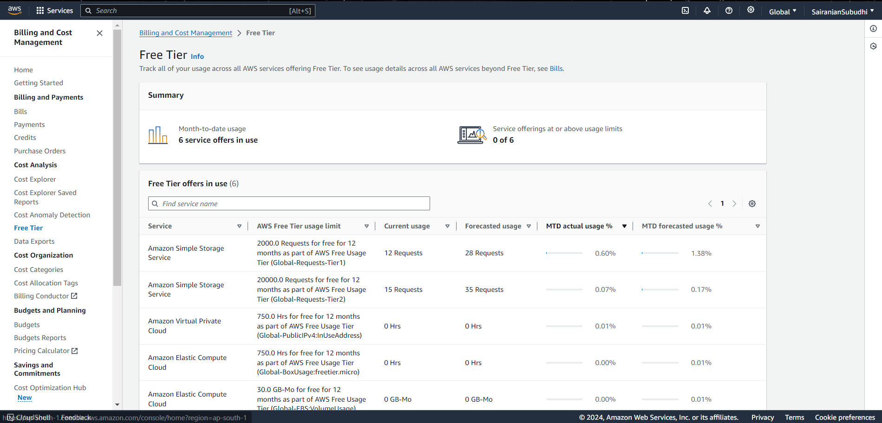

GCP:

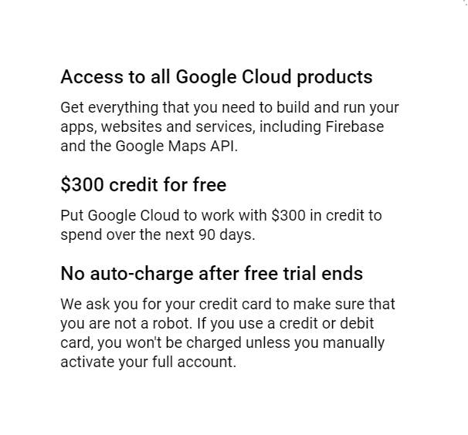

Azure:

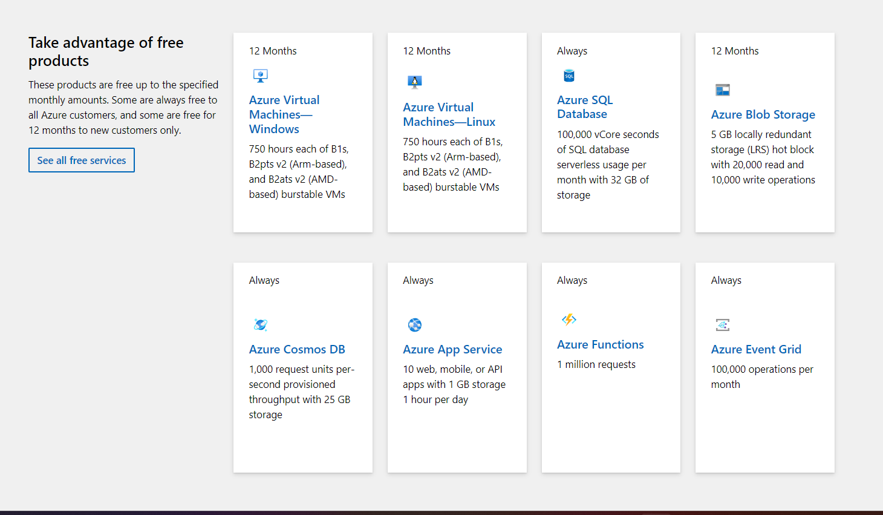

1. Console

AWS:

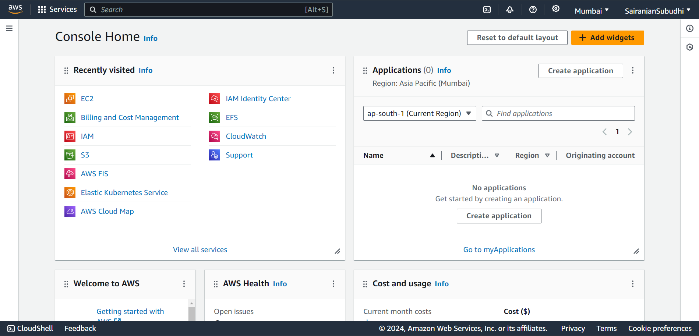

GCP:

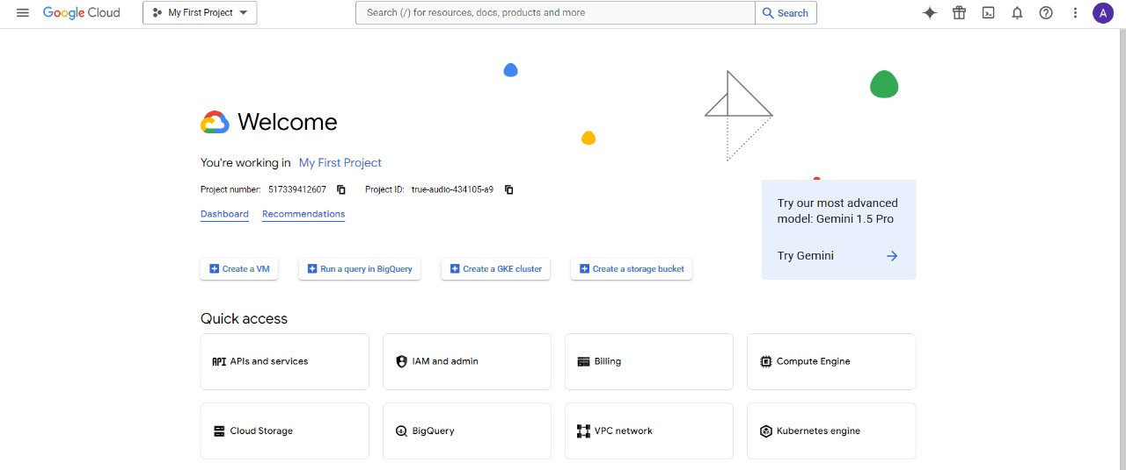

Azure:

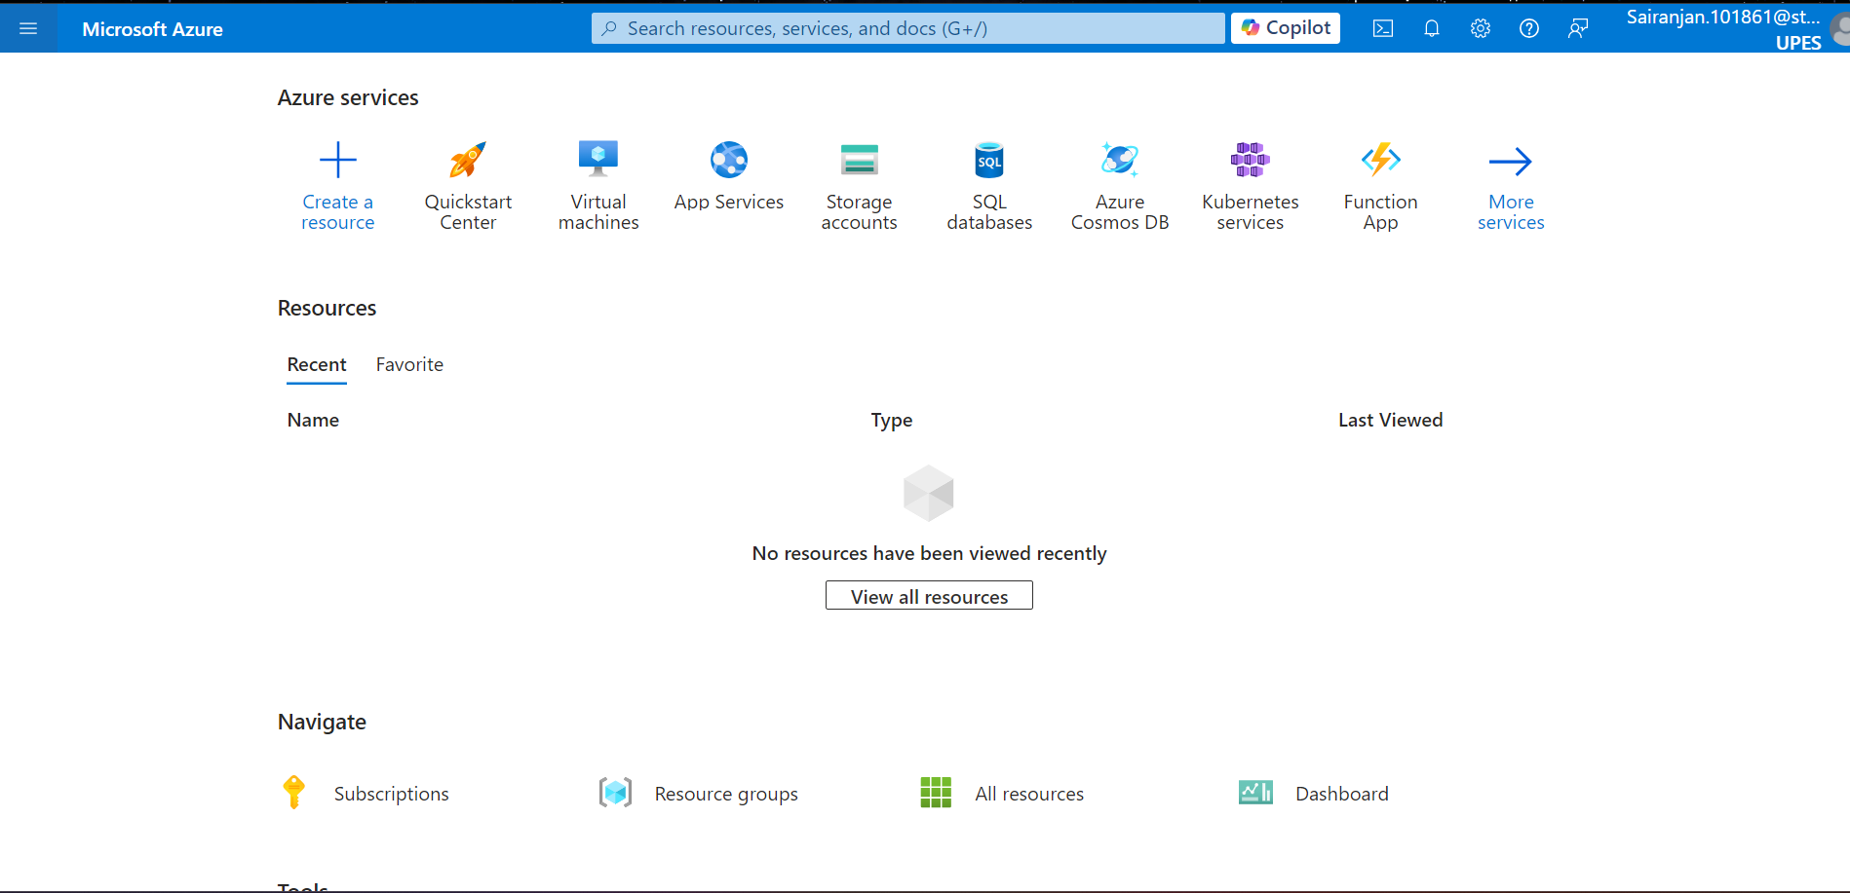

1. Storage:

AWS:

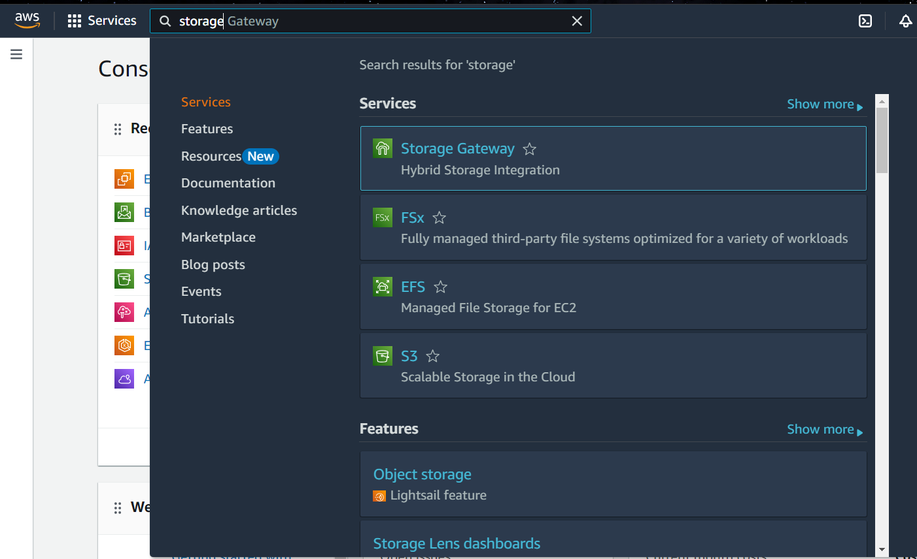

GCP:

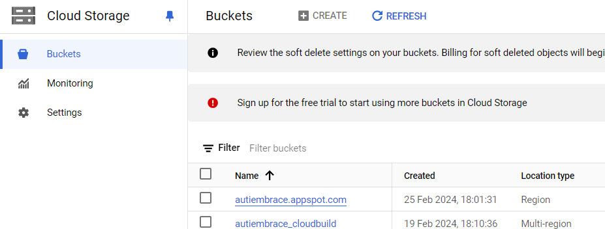

Azure:

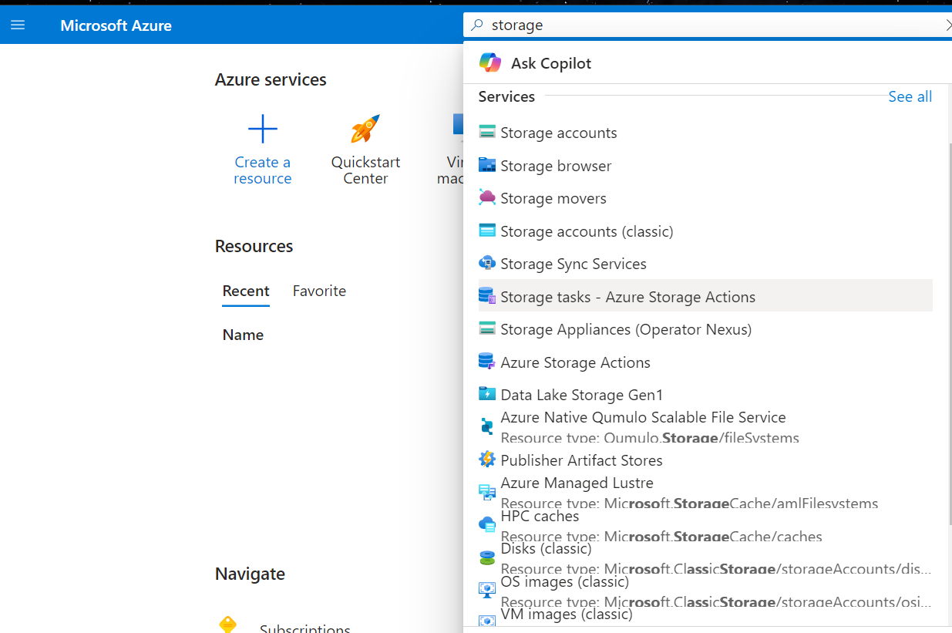

1. Services:

AWS:

**Compute:** EC2, Lambda, Elastic Beanstalk.

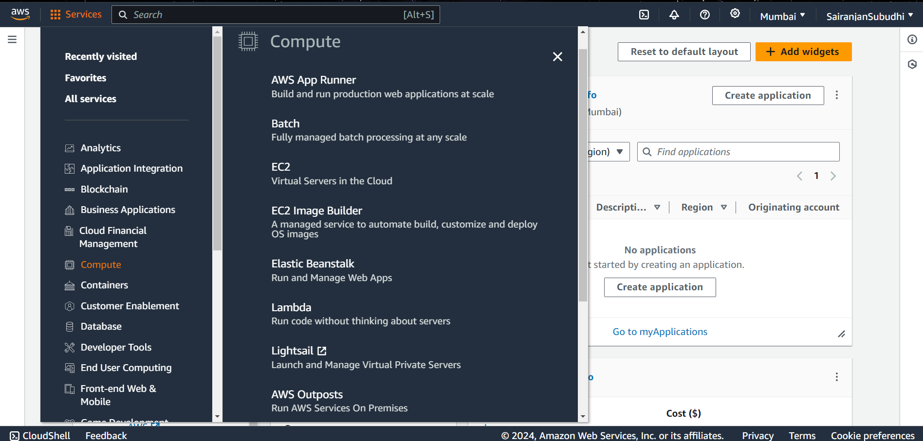

**Database:** RDS, DynamoDB, Redshift, Aurora.

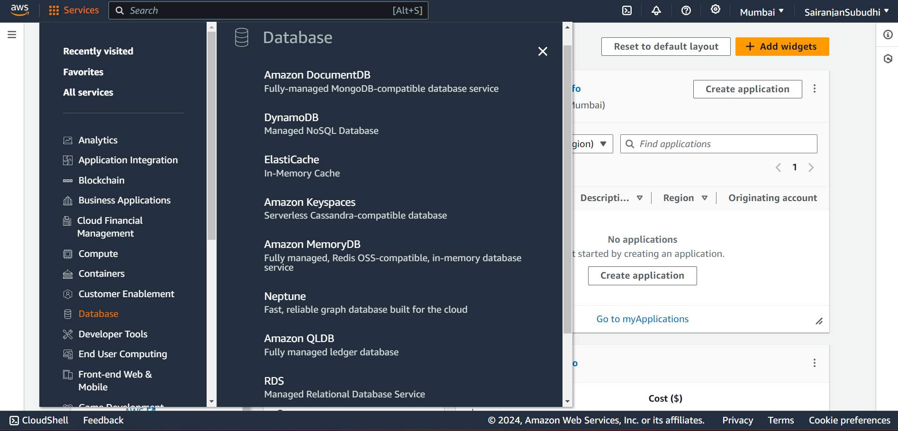

**Developer Tools:** CodePipeline, CodeDeploy, CodeBuild.

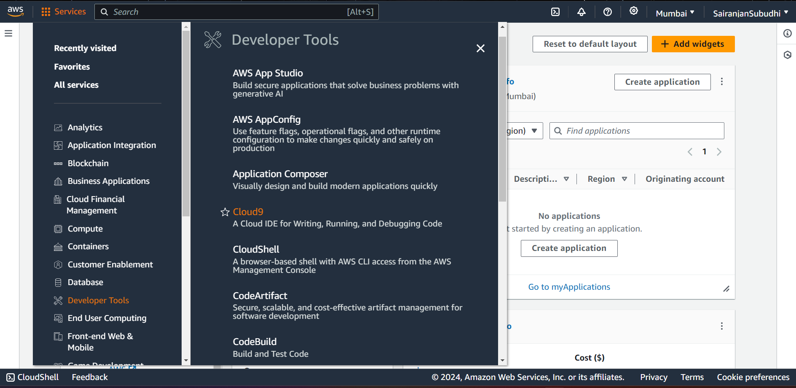

GCP:

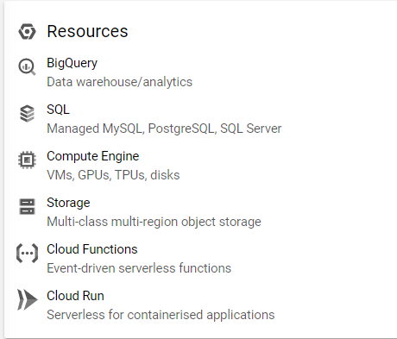

**Compute:** Compute Engine, Cloud Functions.

**Database:** Cloud SQL, Bigtable, Firestore, BigQuery.

**Developer Tools:** Cloud Build, Container Registry, Cloud Source Repositories.

Azure:

